Project 1 Numbers Solution

**Scenario**

There is a requirement to be able to convert an integer into words. For example, 57 needs to be converted into “fifty seven”.

The objective of this project is to develop a method which can convert the numbers 1 through 999 to words. If you have time extend the range up to 2 billion. The method needs to be developed using Test Driven Development (TDD). A standalone application is also required which reads a number from the keyboard and prints out its value in words or “Invalid number”. The program should exit when the user enters 0.

The tools and technologies used are:

* Apache Ant
* jUnit
* Java 8
* Eclipse
* Jenkins
* Git Hub

**Solution :**

This solution is based on exercises(Lesoon) 1 3 4 and 5.

Start your Google Compute Engine virtual machine and connect to it using SSH.

Start by copying the project code directory and the scripts from the two lessons into a Project2 directory.

Perform below steps to install Apache Ant.

* git clone https://github.com/simplilearn-devops/devops-project-3
* curl -O <http://www-eu.apache.org/dist//ant/binaries/apache-ant-1.10.3-bin.zip>
* unzip apache-ant-1.10.3-bin.zip
* ln –s apache-ant-1.10.3 ant

**Set up an Eclipse project**

Start the vncserver on your virtual machine.

Start the VNC client on your local machine and connect to port 5901 at your virtual machine’s external IP address.

Start Eclipse.

Create a new Java project and use the location of the Project2 directory where you copied the starting point code.

Select the project properties -> java build path -> libraries -> add required jar files.

**The unit test java file :**

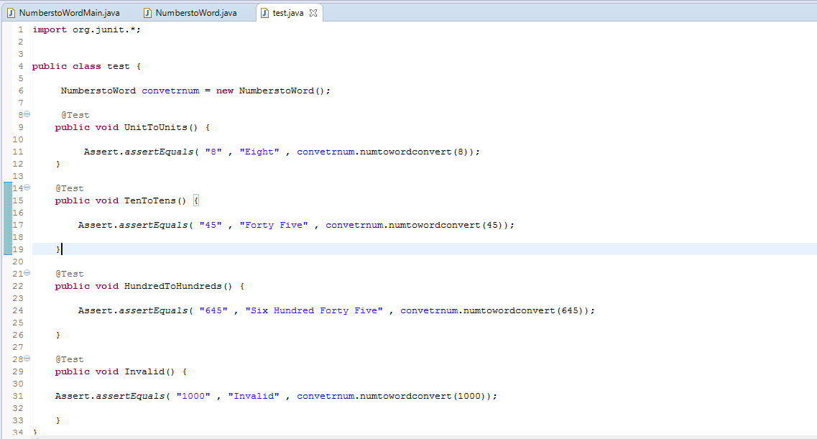

**The number to words Java file :**

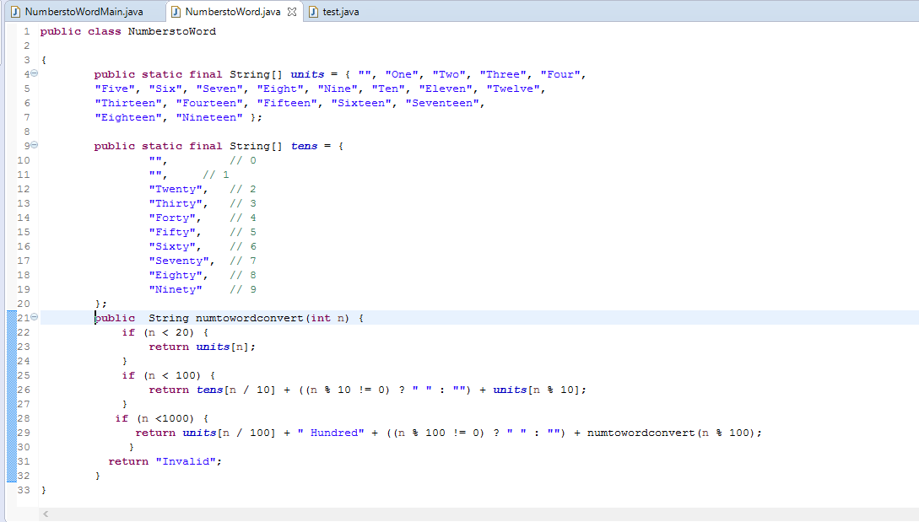

**The main application Java file**

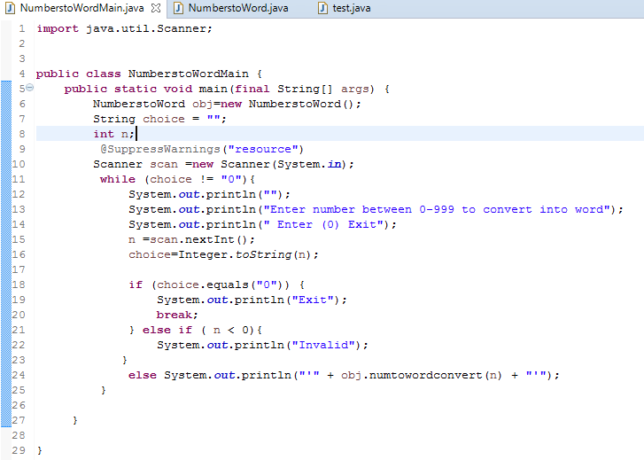

**The test results file from the report directory**

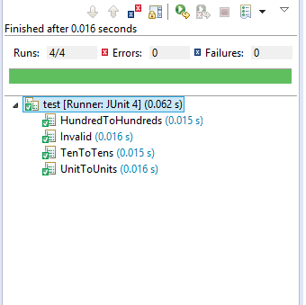

**A screen shot of the application output after running it with a representative set of numbers**

